**VISVESVARAYA TECHNOLOGICAL UNIVERSITY**

"Jnana Sangama", Belagavi - 590018

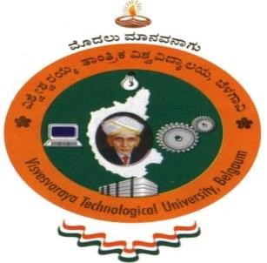

A Report on

**AICTE ACTIVITY**

Submitted in partial fulfillment of the requirement for the award of the degree of

**Bachelor of Engineering in**

**Computer Science and Engineering**

**By**

**ADITI DAS**

**1AY21CS014**

Under the guidance of

**Mrs. BHAVYASHREE S P**

**Assistant Professor**

**Department of Computer Science and Engineering**



# **DEPARTMENT OF COMPUTER SCIENCE AND ENGINEERING**

**ACHARYA INSTITUTE OF TECHNOLOGY**

(Affiliated to Visvesvaraya Technological University, Belagavi) 2022-2023

**ACHARYA INSTITUTE OF TECHNOLOGY**

Acharya Dr. Sarvepalli Radhakrishnan Road, Soladevanahalli, Bengaluru – 560107 (Affiliated to Visvesvaraya Technological University, Belagavi)

**DEPARTMENT OF COMPUTER SCIENCE AND ENGINEERING**



# CERTIFICATE

Certified that the report entitled **AICTE ACTIVITY -** Spreading public awareness is a bonafide activity carried out by **Aditi Das (1AY21CS014)** in partial fulfillment for the award of degree of **Bachelor of Engineering in Computer Science and Engineering of Visvesvaraya Technological University**, **Belagavi** during **4rd semester** in the year **2022-2023.** It is certified that all corrections/suggestions indicated for internal assessments have been incorporated in the report deposited in the departmental library. The activity report **[21NS83]** has been approved as it satisfies the academic requirements in respect of project prescribed for the **Bachelor of Engineering Degree**.

|  |  |  |
| --- | --- | --- |
| Signature of AICTE Coordinator | Signature of HOD | Signature of Principal |
| **Mrs. Bhavyashree S P** | **Dr. Ajith Padyana** | **Dr. Rajeswari** |
| **Assistant Professor**    **External**  **Name of Examiner**   1. **__________________________** 2. **__________________________** | **HOD**  **____________________**  **AICTE Officer ,AIT** | **Principal,AIT**  **Signature with Date**  **____________________**  **____________________** |
|  |  |  |

# DECLARATION

I , **ADITI DAS** ,student of 4rd semester, B.E Computer Science and Engineering, Acharya Institute of Technology, Bangalore, hereby declare that the activity report entitled **“AICTE ACTIVITY -** Spreading public awareness is an authentic activity report of our own work carried out under the supervision and guidance of Mrs. Bhavyashree S P, Assistant Professor and AICTE CSE Department Coordinator, Department of Computer Science and Engineering, Acharya Institute of Technology, Bangalore. I have not submitted the matter embodied to any other University or Institution for the award of any other degree.

Date:

Place: Bengaluru

**ADITI DAS 1AY21CS014**

# ACKNOWLEDGEMENT

We express our gratitude to our institution and management for providing us with good infrastructure, laboratory, facilities and inspiring staff, and whose gratitude was of immense help in completion of this report successfully.

We are deeply indebted to **Dr. Rajeswari,** Principal, Acharya Institute of Technology, Bengaluru, who has been a constant source of enthusiastic inspiration to steer us forward.

We heartily thank **Dr. Ajith Padyana**, Head of the Department, Department of Computer Science and Engineering, Acharya Institute of Technology, Bengaluru, for his valuable support and for rendering us resources for this activity.

We specially thank **Mrs. Varalakshmi B D,** Assistant Professor and AICTE CSE Department Coordinator, Department of Computer Science and Engineering, Acharya Institute of Technology, Bangalore who guided us with valuable suggestions in completing this project at every stage.

We would like to express our sincere thanks and heartfelt gratitude to Computer Science and Engineering staff members, our beloved Parents, Respected Professors, Classmates, Friends and non-teaching staff for their indispensable help at all times.

Last but not the least our respectful thanks to the Almighty.

**ADITI DAS 1AY21CS014**

## INTRODUCTION

The conduction of the activity on ‘Plastic cleanup and Awareness walk’ at Hesaraghatta Lake has provided with an understanding and need to contribute to safeguarding and promoting our environment. With the fast-developing society and vast growth over generations it has become difficult to keep track of the important things that one should be conscious of. Due to this lack of regard for our surroundings we often mistreat our society as a whole and neglect the need to serve a helping hand when required to do so.

By performing this activity not only have we served to spread awareness among others in society but also have developed a self-understanding regards the necessity in maintaining a clean and enriched environment.

**CHAPTER 1**

**OBJECTIVE**

Spreading public awareness is crucial for addressing pressing issues and promoting positive change. By engaging in open discussions, sharing reliable information, and leveraging social media platforms, we can reach a wider audience and inspire collective action. Educating ourselves and others about important matters empowers us to make informed decisions and work together toward creating a more informed, compassionate, and sustainable society.

To spread public awareness, various activities can be undertaken. Conducting informative workshops, seminars, and webinars on relevant topics can educate and engage the public. Creating and distributing informational materials like brochures, flyers, and posters can reach a broader audience. Organizing community events, rallies, and awareness campaigns can generate public interest and participation.

Through this activity, public awareness was spread through the course of action performed. Instead of advising others or encouraging them, physical work was performed to clean up the society and to display a demonstration to the people that a step can be taken by anyone to help clean and safeguard our surrounding.

Keeping our society clean is of paramount importance for several reasons. Firstly, a clean environment promotes better health and well-being among the population, reducing the risk of diseases and improving overall quality of life. Secondly, it enhances the aesthetics of the surroundings, creating a more pleasant and attractive living space for residents and visitors alike. A clean society also fosters a sense of pride and responsibility among its members, encouraging them to take ownership of their environment.

By actively participating in cleaning initiatives and promoting cleanliness, individuals can spread positive awareness in various ways. Leading by example, such actions inspire others to follow suit and adopt responsible waste management practices. These efforts can also spark conversations and discussions about the importance of environmental preservation, raising awareness about the impact of pollution and litter on our ecosystems.

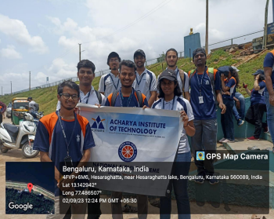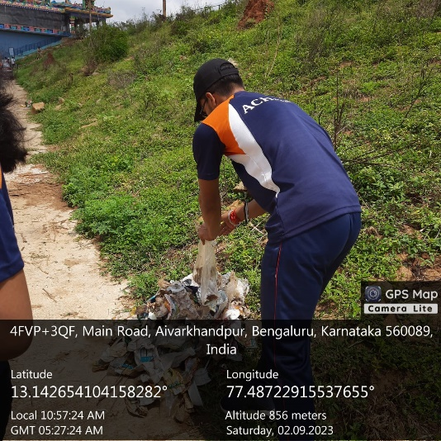

When communities collectively engage in clean-up drives and conservation projects, they build

a sense of unity and camaraderie, reinforcing the idea that every individual's actions contribute to the greater good. This sense of shared responsibility helps in nurturing a culture of sustainability and mindful consumption.

Moreover, public awareness about the significance of cleanliness can extend beyond physical environments. It can inspire people to adopt eco-friendly habits in their daily lives, such as reducing plastic usage, recycling, and conserving resources. As more individuals embrace these practices, a positive ripple effect is created, leading to a broader societal shift towards a greener and cleaner future.

Overall, a clean society not only improves the immediate living conditions but also sets the foundation for a more conscious and environmentally responsible community. Through promoting cleanliness and actively participating in clean-up efforts, individuals can create positive awareness that influences others to join the cause, resulting in a cleaner, healthier, and more sustainable society for future generations.

**CHAPTER 2**

**ABOUT THE PLACE**

Hesaraghatta Lake, is a man-made reservoir located in the state of Karnataka, India. It is situated in the outskirts of Bangalore, approximately 20 kilometres to the northwest of the city centre. The lake is one of the prominent water bodies in the region and has both historical and ecological significance.

It originally served as a vital source of drinking water for Bangalore and facilitated irrigation in the surrounding agricultural areas. Over time, the lake has evolved into a popular recreational destination, offering boating, picnicking, and birdwatching opportunities. Its wetlands attract a diverse range of bird species, making it an important site for ornithologists and nature enthusiasts.

However, the lake faces challenges such as water pollution and encroachment due to urbanization. Conservation efforts are underway to protect its biodiversity and ecological balance. Hesaraghatta Lake remains a prominent feature of Bangalore's landscape, reflecting its historical heritage and ecological vibrancy.

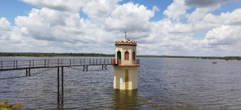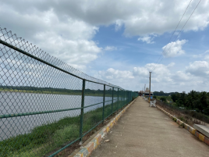

**CHAPTER 3**

**CONDUCTION OF THE ACTIVITY**

By actively participating in this activity, as an individual and part of this society we as students have contributed to the safekeeping of the environment. Hesaraghatta Lake, one of the public areas which is frequently visited by the people, has been polluted and disrupted with the gathering of many wastes. This waste has been neglected and gathered on land and in the water by the continuous littering of the people.

This activity was carried out by the formation of several groups, where the students actively participated in gathering the waste over the regions they were assigned to. Precautions and close observations were taken by the staff in charge, which had led the students to do their parts carefully and sincerely.

By the conduction of such activity, one recognizes that it is not only important to be apart of nature but to take care of it as well. Even though a few hours were devoted in cleaning the area, it has made a major impact in the surrounding.

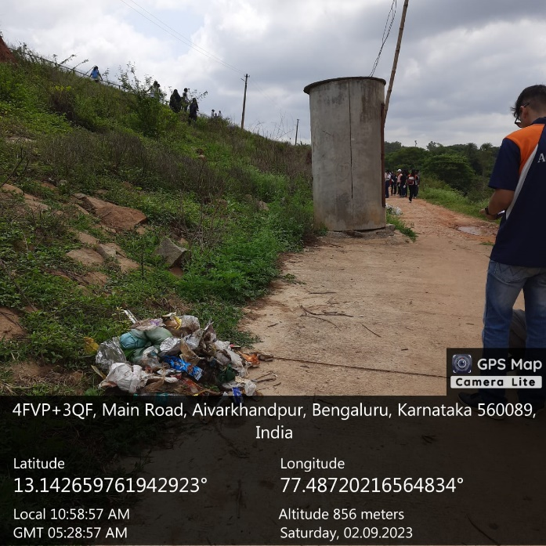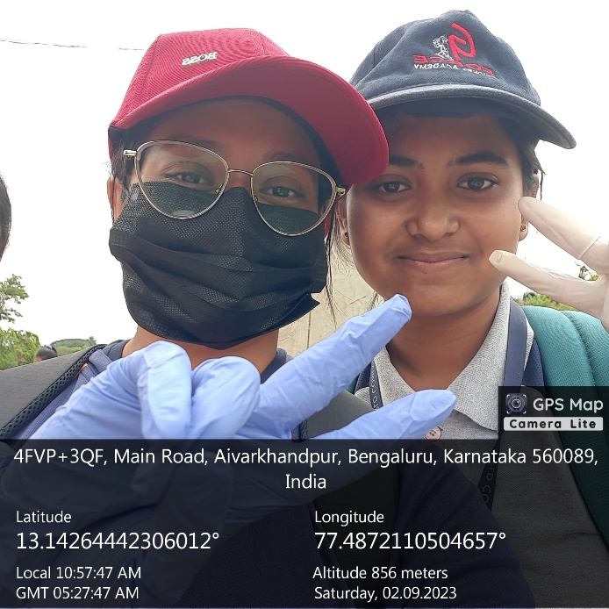

**CONCLUSION**

Since the natural resources of the world are not unlimited, the effective use of resources and the access of future generations to these resources concern all societies on a global scale. From this point of view, waste management strategies should be examined in terms of medical, household, and other waste types. Thereby, this study aims to examine the level of public awareness in waste management by studying the perception, perspective, practice about waste’s aspects.

The survey in this study mentions questions on waste management knowledge, public awareness, and behaviors among social interviews of pharmacy students receiving laboratory training in the field of health. Internal consistency reliability is used to verify the uniformity of questions in this study. Pearson correlation, t-test, and the analysis of variance (ANOVA) are performed to study the differences between groups.

The results of the data analysis show that public awareness and waste management knowledge, public awareness, and behaviors have a significant positive correlation. The first module’s outcomes of the questionnaire reveal a high degree of waste management among students. On the contrary, woman participants demonstrate a higher public awareness and application of the environment. Furthermore, there are significant correlations between the other modules and demographic factors with family education.

According to the results, the public awareness of the participants who were members of an environmental organization is different from others. Finally, the participants state that the problem of not managing wastes effectively causes the most damage to the soil and all other natural resources after water.